**DAILY ONLINE ACTIVITIES SUMMARY**

|  |  |  |  |  |  |  |  |  |
| --- | --- | --- | --- | --- | --- | --- | --- | --- |
| **Date:** | **22/06/2020** | | | | | **Name:** | **SPOORTI DAROJI** | |
| **Sem & Sec** | **4th SEM. & ‘B’ SEC.** | | | | | **USN:** | **4AL18CS088** | |
| **Online Test Summary** | | | | | | | | |
| **Subject** | | **------** | | | | | | |
| **Max. Marks** | | **--** | | **Score** | | | **--** | |
| **Certification Course Summary** | | | | | | | | |
| **Course** | **Introduction to Cybersecurity** | | | | | | | |
| **Certificate Provider** | | | **CISCO** | | **Duration** | | | **15Hrs.** |
| **Coding Challenges** | | | | | | | | |
| **----** | | | | | | | | |
| **Status: ----** | | | | | | | | |
| **Uploaded the report in Github** | | | | | **Yes** | | | |
| **If yes Repository name** | | | | | [alvas-education-foundation](https://github.com/alvas-education-foundation)/[spoorti_daroji](https://github.com/alvas-education-foundation/spoorti_daroji) [spoorti_daroji](https://github.com/alvas-education-foundation/spoorti_daroji)/coding_solutions/ | | | |
| **Uploaded the report in slack** | | | | | **Yes** | | | |

**Online Test Summary: No internals conducted.**

**Online Certification course Summary:**

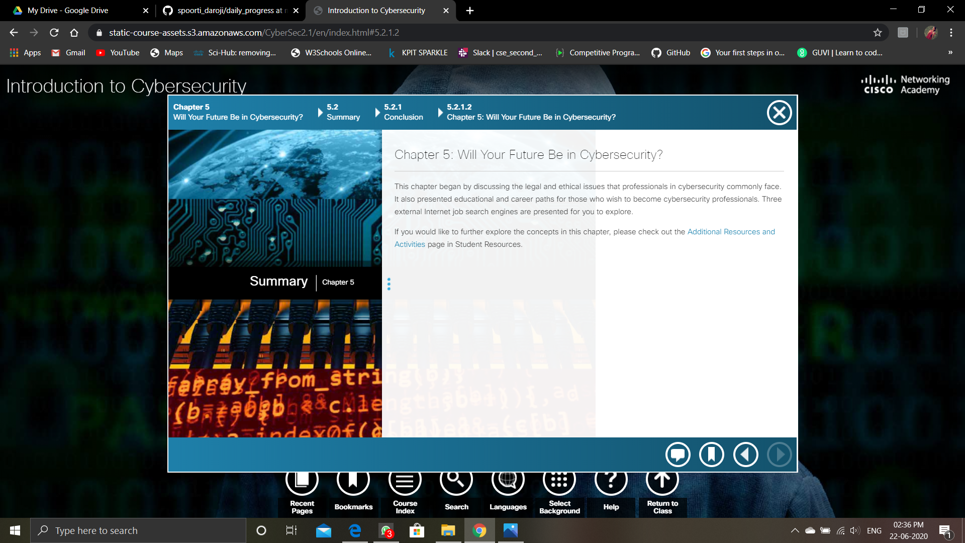

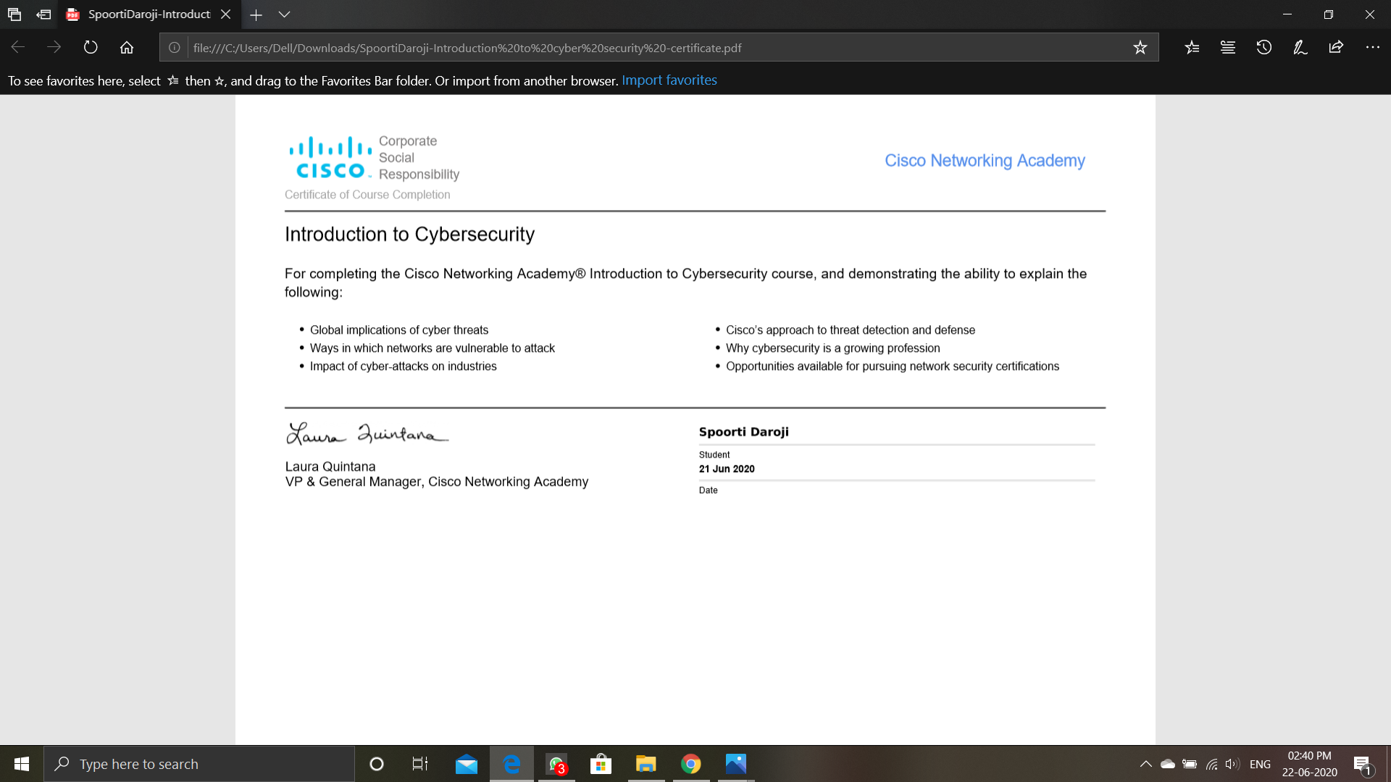

**Online Coding Summary: No programs given today.**